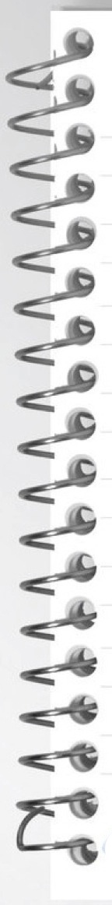

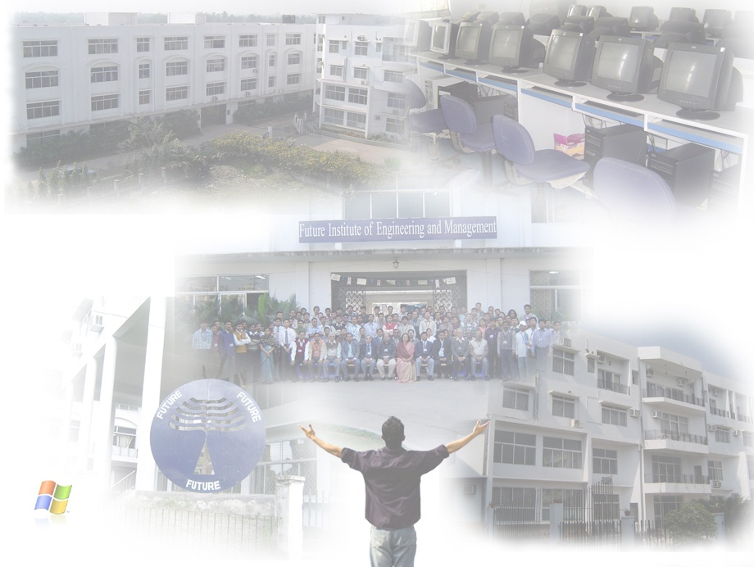

**Data Structure and Algorithm Lab (C) - PCC-CS391**

**REPORT ON:** …………………………..………………………………………………………………Lab.

**ARNA CHAULIA**

**NAME:** …………………………………………………………………………………………………………..

**COMPUTER SCIENCE & ENGINEERING**

**DEPARTMENT:** ……………………………………………………………………………………………..

**3RD**

**22/CSE/052**

**CSE-II**

**C**

**ROLL NO: .**……………..….…… **SEM:** …….…….… **GRP:** ….…… **SECTION:** ……..........

**1**

**I**

**ASSIGNMENT NO:** ………..……**PROGRAM NO:** …..………………………………………....



**TITLE / OBJECTIVE:**

**UNDERSTANDING BASIC ARRAY OPERATIONS USING USER DEFINED FUNCTIONS :**

1. **Insertion , 2. Deletion , 3. Reversing , 4. Searching , 5. Sorting,**
2. **Display**

.…………………………………………………..…………………………………..................................

……….………………………………………………………………………………..................................

………….……………………………………………………………………………..................................

………….……………………………………………………………………………..................................

………….……………………………………………………………………….…….................................



……….………………………………………………………………………………..................................

………….……………………………………………………………………………..................................

………….……………………………………………………………………………..................................



**31/08/2023**

**07/09/2023**

**PERFORMANCE DATE:** …....……………….. **SUBMISSION DATE:** ………………….......

**EXAMINER’S SIGNATURE:** ……………………………………………………………………………..